**Graph Application (Lab Report)**

**Algorithms:**

* Shortest simple paths – Finds the simplest path between a source to a target, begins from the shortest.

Parameters: (Graph, Source, Target, Weight)

Uses: This algorithm is great for when all you care about is getting a simple path created instead of a more complex/specific path, but still want some options/different paths.

* A* path – Returns a list in a shortest path method but only returns one, even if there are more paths.

Parameters: (Graph, Source, Target, Heuristic, Weight)

Uses: Great if you just want a single short path created.

* Double edge swap – Keeps node degrees at a fixed point but swaps two edges.

Parameters: (Graph, Number of swaps, Max tries)

Uses: Allows you to just swap two edges without restructuring the graph.

**Results:**

**Adjacency List:**



**Edge List:**

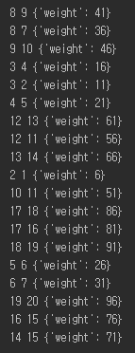

**Shortest Simple Paths:**

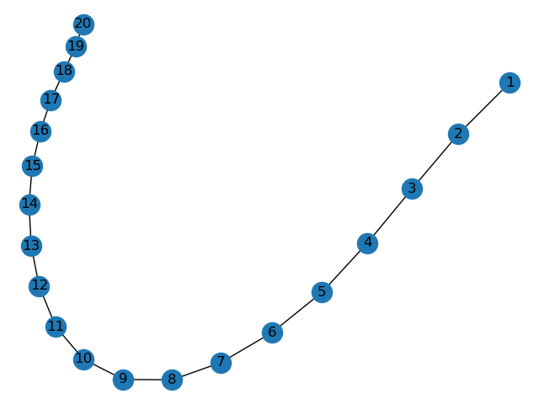

**A* Paths :**

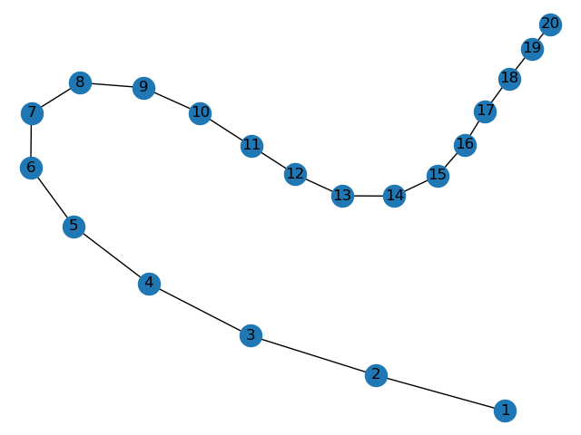

**Double Edge Swap:**

